HONEYPOT: DECOY ZONE

MAJOR PROJECT REPORT

CANDIDATE'S DECLARATION

ACKNOWLEDGEMENT

ABSTRACT
In today’s cybersecurity landscape, deception has emerged as a proactive defense strategy, and honeypots are at the forefront of this approach. A honeypot is a decoy system or service designed to attract attackers by mimicking legitimate targets. Once engaged, it allows defenders to monitor malicious behavior, gather intelligence, and strengthen overall security posture all without risking real assets.
Honeypots operate on a simple but powerful principle: any interaction with them is inherently suspicious, since they serve no legitimate users. This makes them highly effective at filtering out false positives and identifying genuine threats. They are typically categorized as low-interaction or high-interaction systems. Low-interaction honeypots emulate basic services and are easy to deploy, ideal for detecting automated attacks like scans and brute-force attempts. High-interaction honeypots simulate full operating systems, offering deeper insights into attacker tactics and techniques. Depending on their purpose, honeypots are further classified as research or production systems. Research honeypots are used to study emerging threats and contribute to threat intelligence databases. Production honeypots are deployed within live environments to detect intrusions and divert attackers from critical infrastructure. Both types offer valuable data for forensic analysis and incident response.
The benefits of honeypots are multifaceted. They enable early detection, support behavioral analysis, and provide forensic evidence for post-attack investigations. Honeypots also assist in threat attribution, helping identify attackers through IP tracing, malware signatures, and command patterns. Additionally, they serve as training environments for security teams, offering realistic scenarios for practicing defense strategies.
However, honeypots must be carefully managed. If misconfigured or poorly isolated, they can be exploited to attack internal systems. Skilled adversaries may also detect honeypots and avoid them, reducing their effectiveness. Proper containment, segmentation, and monitoring are essential for safe deployment. As threats evolve, honeypots have grown more sophisticated expanding into honeynets and deception platforms that simulate entire networks and integrate fake credentials, decoy files, and bogus user accounts. These systems confuse attackers while collecting valuable intelligence.

TABLE OF CONTENT

ABSTRACT 4
TABLE OF CONTENT 5
TABLE OF FIGURES 7
CHAPTER 1 8
INTRODUCTION TO HONEYPOT 8
1.1 Introduction to Honeypot 8
1.2 Introduction to Honeynet 9
1.3 Relevance of Honeypot to Cybersecurity 10
1.4 Objective 11
1.5 Scope 11
CHAPTER 2 12
PROJECT OVERVIEW: DEVELOPMENT OF HONEYPOT 12
2.1 Purpose and Functionality of Project 12
2.2 Tools and Technologies 13
2.3 Development Process 14
2.4 Testing and Evaluation 16
2.5 Limitations and Challenges 16
2.6 Applications and Use Cases 17
CHAPTER 3 18
TECHNICAL DESIGN AND IMPLEMENTATION 18
3.1 Architecture of Honeypot System 18
3.2 Key Components 19
3.3 Detailed Workflow of Honeypot 21
CHAPTER 4 23
METHODOLOGY 23
4.1 Honeypot Operation Workflow 23
4.2 Analysis of Honeypot Data 24
4.3 Security and Containment Measures 25
4.4 Threat Interaction Logging and Data Management 25
CHAPTER 5 26
PROJECT VISUALS 26
5.1 Visualization of Project and Code Snippet 26
CHAPTER 6 29
EXISTING HONEYPOT SYSTEM 29
6.1 Introduction 29
6.2 Overview of Popular Tools 29
CHAPTER 7 31
CASE STUDY - ATTACKS CAPTURED BY THE HONEYPOT 31
CHAPTER 8 32
PROJECT REQUIREMENTS 32
8.1 Software Requirements 32
8.2 Hardware Requirements 32
CHAPTER 9 33
FUTURE SCOPE 33
CHAPTER 10 34
CONCLUSION 34
REFERENCES 35

TABLE OF FIGURES
Figure 1 Honeypot 9
Figure 2 Honeynet 10
Figure 3 Functionalities 13
Figure 4 Programming Language 13
Figure 5 Development Environment 14
Figure 6 Development Process 15
Figure 7 Test Environment 16
Figure 8 Architecture 18
Figure 9 Workflow Layout 18
Figure 10 Configuration 19
Figure 11 Authentication 20
Figure 12 Logs 20
Figure 13 Detailed workflow 21
Figure 14 Honeypot Process 24
Figure 15 Isolated Environment 25
Figure 16 Stored Logs 25
Figure 17 honeypot.py 26
Figure 18 visualize.py 26
Figure 19 logger.py 26
Figure 20 Configuration 27
Figure 21 Dashboard 27
Figure 22 Logs file 27
Figure 23 Command file 28
Figure 24 Loggings 28
Figure 25 Captured attack 28

CHAPTER 1

INTRODUCTION TO HONEYPOT
Today we live in a digital era where all aspects of our lives depend on the network, computer and other electronic devices, and software applications. All critical infrastructure such as the banking system, healthcare, financial institutions, governments, and manufacturing industries use devices connected to the Internet as a core part of their operations. Some of their information, such as intellectual property, financial data, and personal data, can be sensitive for unauthorized access or exposure that could have negative consequences. This information gives intruders and threat actors to infiltrate them for financial gain, extortion, political or social motives, or just vandalism.
Cyber-attack is now an international concern that hacks the system, and other security attacks could endanger the global economy. Therefore, it is essential to have an excellent cybersecurity strategy to protect sensitive information from high-profile security breaches. Furthermore, as the volume of cyber-attacks grows, companies and organizations, especially those that deal with information related to national security, health, or financial records, need to use strong cybersecurity measures and processes to protect their sensitive business and personal information.
Cyber Security's main objective is to ensure data protection. The security community provides
a triangle of three related principles to protect the data from cyber-attacks. This principle is called the CIA triad. The CIA model is designed to guide policies for an organization's information security infrastructure. When any security breaches are found, one or more of these principles has been violated.
A honeypot is a decoy host or server that emulates a business infrastructure, such as a workstation, server, or database. It is designed to lure attackers and collect threat intelligence based on their interactions. Honeypots can be categorized into two types: Honeypots: These are singular decoy systems that attract cyber attackers. Honeynets: These consist of multiple honeypots that simulate a network environment, allowing for more extensive data collection on attacker behaviour

Introduction to Honeypot
A honeypot is a cybersecurity mechanism that uses a manufactured attack target to lure cybercriminals away from legitimate targets. They also gather intelligence about the identity, methods and motivations of adversaries. A honeypot can be modelled after any digital asset, including software applications, servers or the network itself. It is intentionally and purposefully designed to look like a legitimate target, resembling the model in terms of structure, components and content. This is meant to convince the adversary that they have accessed the actual system and encourage them to spend time within this controlled environment. The honeypot serves as a decoy, distracting cybercriminals from actual targets. It can also serve as a reconnaissance tool, using their intrusion attempts to assess the adversary’s techniques, capabilities and sophistication. The intelligence gathered from honeypots is useful in helping organizations evolve and enhance their cybersecurity strategy in response to real-world threats and identify potential blind spots in the existing architecture, information and network security.
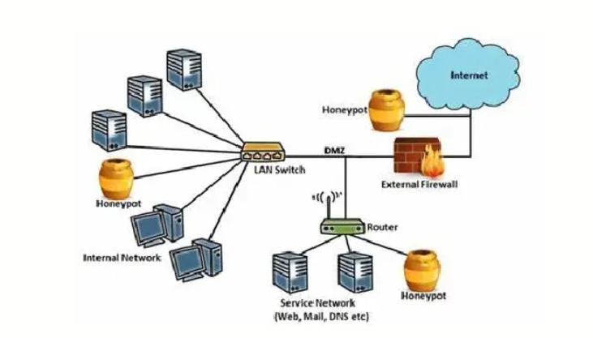
Figure 1 Honeypot

Introduction to Honeynet
A honeynet is a network of honeypots that is designed to look like a real network, complete with multiple systems, databases, servers, routers and other digital assets. Since the honeynet, or honeypot system, mimics the sprawling nature of a typical network, it tends to engage cybercriminals for a longer period of time. Given the size of the honeynet, it is also possible to manipulate the environment, luring adversaries deeper into the system in order to gather more intelligence about their capabilities or their identities. A honeynet is a vulnerable and simulated computer network using a decoy server designed to test network security. Honeynets are developed in order to help computer security experts to improve security for networks and systems. Although it may appear to a hacker as a legitimate network, it is actually hosted on a single server. How it is used in cyber security? In cybersecurity, a honeypot is a security tool that can help computer systems defend against cyber-attacks in unique ways. This network-attached system is used as a decoy to distract cyber attackers from their real targets. Since a honeypot could serve as a launch pad for further intrusion, ensure all honeypots are well secured. A 'honeywall' can provide basic honeypot security and stop attacks directed against the honeypot from ever getting into your live system.
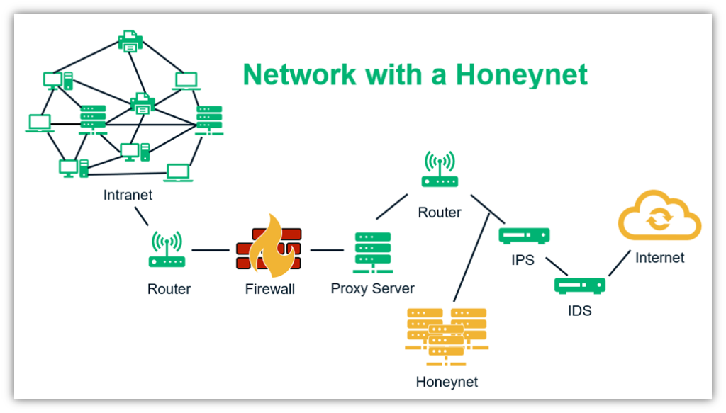
Figure 2 Honeynet

Relevance of Honeypot to Cybersecurity
The basic premise of the honeypot is that it should be designed to look like the network target an organization is trying to defend. A honeypot trap can be manufactured to look like a payment gateway, which is a popular target for hackers because it contains rich amounts of personal information and transaction details, such as encoded credit card numbers or bank account information. A honeypot or honeynet can also resemble a database, which would lure actors that are interested in gathering intellectual property (IP), trade secrets or other valuable sensitive information. A honeypot may even appear to contain potentially compromising information or photos as a way to entrap adversaries whose goal is to harm the reputation of an individual or engage in ransomware techniques. Once inside the network, it is possible to track cybercriminals’ movements to better understand their methods and motivations. This will help the organization adapt existing security protocols in order to thwart similar attacks on legitimate targets in the future. To make honeypots more attractive, they often contain deliberate but not necessarily obvious security vulnerabilities. Given the advanced nature of many digital adversaries, it is important for organizations to be strategic about how easily a honeypot can be accessed. An insufficiently secured network is unlikely to trick a sophisticated adversary and may even result in the bad actor providing misinformation or otherwise manipulating the environment to reduce the efficacy of the tool. A honeypot is software that serves as bait to lure in hackers. In simpler terms, envision a hacker instead of a bear. Instead of offering the bear’s irresistible honey, cybercriminals are lured in with cyber bait — anything that is attractive to the hacker. What exactly is this bait? For example, hackers would be very interested in applications and data that act like a legitimate computer system, contain sensitive information, and aren’t secure. Anything that looks like it contains security vulnerabilities will be very attractive to hackers. While monitoring traffic to honeypot systems, security analysts can better understand three key data points: where cybercriminals are coming from, how they operate, and what they want. Monitoring honeypots can help determine which security measures are working — and which ones need improvement.

Objective
The goal of this project is to build an SSH honeypot designed to collect failed login attempts and session metadata for cybersecurity analysis. The honeypot will serve as an educational tool and a source of actionable threat intelligence by capturing attacker behaviour, tools, credential patterns, and tactics. It will be operated in a strictly controlled, segmented network environment with enforced egress limitations and monitoring to prevent misuse. Key data such as IP addresses, timestamps, usernames, and authentication methods will be logged, while avoiding the collection of sensitive payloads. A virtualized or containerized setup ensures easy rollback and analysis, with snapshots taken periodically for forensic purposes. Legal and ethical considerations are prioritized, with all activities conducted under responsible use policies. The findings will be used to improve defensive measures, educate others through case studies, and contribute indicators of compromise to the security community without publishing exploit code. This honeypot serves as a foundation for developing deeper insights into attacker behaviour and strengthening overall cyber defence strategies.

Scope
This project focuses specifically on SSH-based attacks, particularly brute-force login attempts and basic command execution patterns. It captures metadata such as attacker IPs, attempted credentials, and session behaviour for analysis. The honeypot is designed for research and cybersecurity education, not for interacting with or deterring real adversaries in production or critical infrastructure environments. Data collected will be used to study attacker behaviour, enhance defensive strategies, and support educational use, with strict controls on data handling, privacy, and ethical boundaries.

CHAPTER 2

PROJECT OVERVIEW: DEVELOPMENT OF HONEYPOT

2.1 Purpose and Functionality of Project
Purpose
The purpose of a project is to develop a honeypot that can efficiently simulate an SSH server, attract unauthorized login attempts, and systematically log attacker data and behaviour for security research. It captures the attacker TTPs, when unauthorized person tries to gain access the honeypot captures the TTPs of attacker that from which IP address the unauthorized person is trying to gain access. The different tactics, techniques and procedure which the unauthorized gainer will try that all will get captured in a log file with different attributes. There are two log file which capture the TTPs one where unauthorized person try but not able to gain access and one attacker gain the access and what command does it try. These logs are also stored in the form of graph where it shows IP which try to gain access, it shows how many attempts were made by particular IP to gain access.
This tool is generally developed for cybersecurity learners and professionals to identify the different attacker who try to gain access from which IP address at what timestamp and whether the attacker was able to gain access or not, which will help the analyst to get to know that from which address the attacks are performed mostly, so that they can further block the address to enter their network and it will also the organization to make their network security and make the security compliances to increase their network security.
Functionality
The core functionality of a honeypot is as simple:
To develop the Honeypot project, we use Python. The project will be modular, meaning we will break down functionalities into various Python files. The functionality of honeypot was that there is certain password and username if attacker met that it gets access, where he runs command but it’s the honeypot system not the real server, other attacker try brute-force to gain access.
Setting up the development environment
Creating an SSH-based honeypot
Implementing logging mechanisms

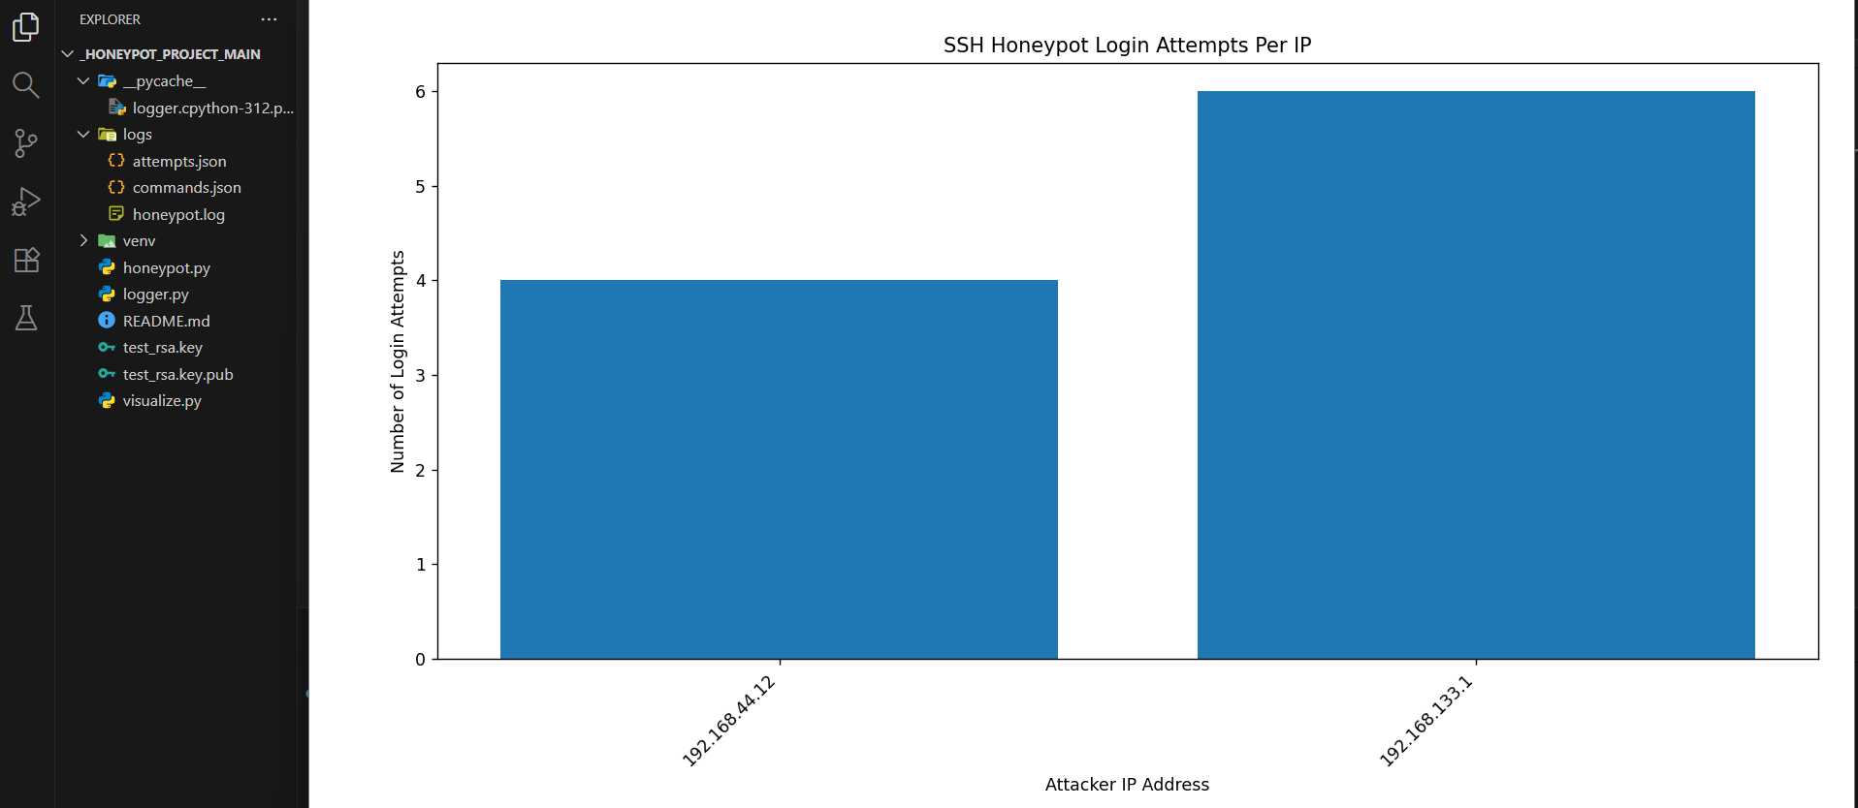
Figure 3 Functionalities

2.2 Tools and Technologies
Programming Language: The programming language used to develop a tool is Python programming language. Python programming is used to develop a tool because Python is a versatile, high-level, and widely-used programming language which is known for its readability and ease of use. It has extensive libraries and frameworks that make it ideal for honeypot projects.
Key libraries / frameworks
Paramiko - Used to emulate the SSH protocol and handle authentication sessions.
Matplotlib - Generates visual representations of attack data and trends.
Threading- Enables handling of multiple concurrent SSH connections.
socket - Establishes low-level TCP server to accept incoming SSH connection requests.
logging - Records attacker activity and system events for analysis and auditing.

Figure 4 Programming Language
Development Environment: Visual Studio Code (VS Code) is a free and lightweight code editor that I used to develop the SSH honeypot project. It provides an easy-to-navigate interface with an integrated terminal, which made running Python scripts and monitoring output very convenient. The built-in debugging features helped me find and fix errors quickly during development. VS Code also supports virtual environments, allowing me to manage project dependencies without affecting my system Python setup. Overall, using VS Code made the development process more efficient and organized, providing a smooth workflow for writing, testing, and debugging.

Figure 5 Development Environment

2.3 Development Process
Requirements Gathering: The first step was to define the honeypot’s goals and requirements. It should simulate an SSH server, accept incoming SSH connections, capture authentication attempts such as (usernames, passwords, source IPs, timestamps), log attacker commands and store data in a format suitable for later analysis and visualization. It was later tested in isolated environment so that that it does not affect normal outbound network.
Design and Planning: I designed a modular architecture to facilitate the development process showing how the network listener, SSH session handler, logging module, storage, and visualization components interact. The project was broken into modules (networking, SSH emulation, session management, logging, visualization) to make development manageable and to allow future extensions.
Environment Setup: The development was done on a Windows operating system using Visual Studio Code as code editor. Python 3.12.4 was installed on Windows and the required libraries such as paramiko, socket, threading, logging, matplotlib, and json etc. were installed inside environment to avoid the Collison with outbound environment. A Python virtual environment was created and managed within VS Code’s integrated terminal to handle dependencies and keep the project organized. VS Code provided an integrated terminal, debugging tools, and source control features that made writing, testing, and debugging the SSH honeypot efficient and convenient.
Implementation: Development was done in incremental steps:
- Network Listener: Use socket to bind to a port and accept incoming TCP connections.
- SSH connection: Use paramiko to handle SSH protocol negotiation and authentication attempts.
- Logging & Storage: Use the logging module (structured JSON logs) to record timestamps, source IPs, attempted credentials, and command inputs; store logs in files.
- Visualization: Use matplotlib to generate charts (attempts over time, top usernames, source IP distribution) for reporting.
Testing and Debugging: I tested the honeypot in isolated virtual lab by connecting from different clients and running simulated brute-force tools and scripts to verify logging accuracy, session handling, and resilience. Bugs were found via structured tests and fixed iteratively.
Optimization: To improve performance and reliability I implemented concurrent session handling, limited maximum sessions per source IP, added log rotation and retention policies, and tuned timeouts to reduce resource use.
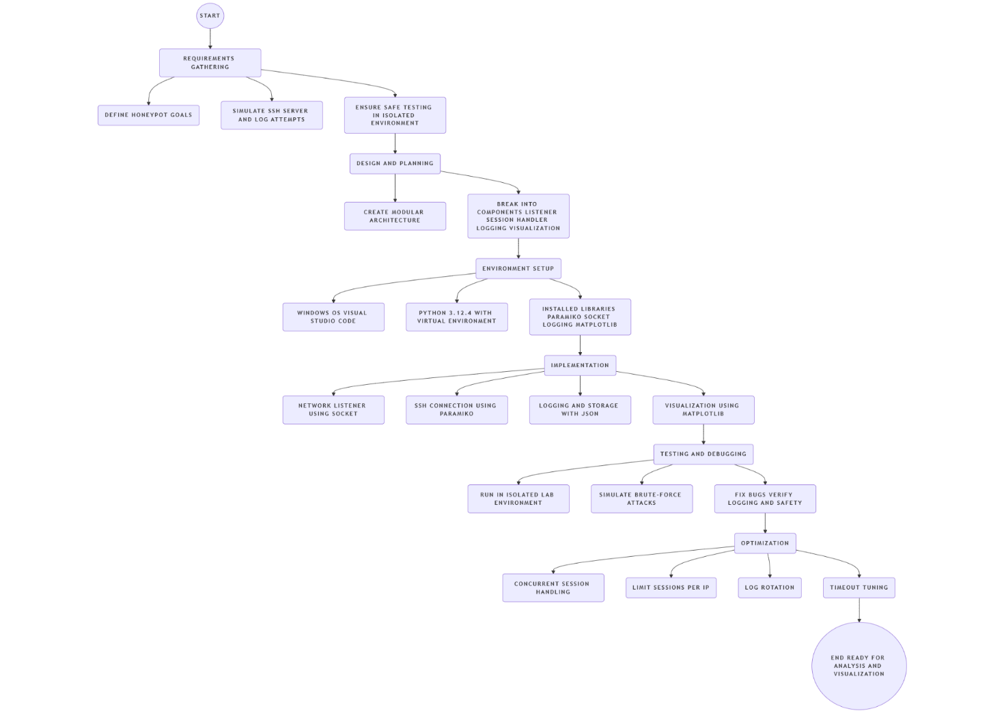
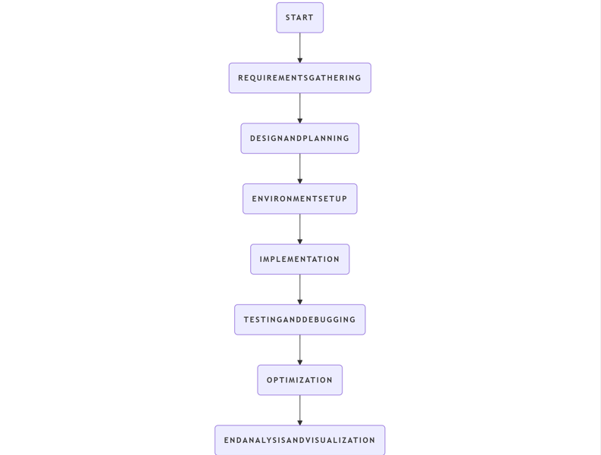
Figure 6 Development Process

2.4 Testing and Evaluation
Testing Environments: For testing the functionality of honeypot system there was safe environment was used. There was attempt from various machines to test the honeypot system as for ssh the port is 22 but for controlled environment the port was changed to 2222 which make the testing of honeypot system isolated.
Test Result: it was tested on isolated environment where in one access was denied as attacker try the brute-force to get the access. But there was another attempt where by chance attacker get access it was trap in honeypot there is username and password which if attacker met it get an access where attacker try different command which look like real terminal but that honeypot decoy where attacker try different commands which are stored in logs to analysis.
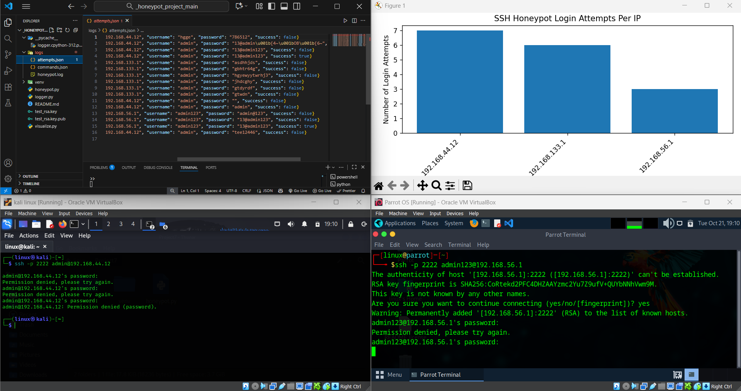
Figure 7 Test Environment

2.5 Limitations and Challenges
- Dependency and False positives: The honeypot sometimes logged benign or misconfigured scanners and background network noise as malicious activity, which required extra filtering to avoid misleading conclusions. Installing and configuring dependencies (e.g., paramiko, Python versions) across different systems occasionally caused compatibility problems during setup.
- Ethical concerns and Network instability: Running a honeypot raises responsibility issues logging credentials and attacker input must be handled with clear scope, retention, and legal considerations to avoid privacy or misuse problems. Network interruptions affected session completeness; misconfiguration could allow the honeypot to be used as a pivot to other systems if outbound rules were not strict.
Improvements Made: Based on testing feedback, the following enhancements were implemented:
- Optimized multithreading to ensure better resource management during large-scale scans.
- Different Json file for successful attempt and non-successful attempt were separated with different log file.
- There was range slide was added to graph visualize to adjust a graph according to configure the subplots.

2.6 Applications and Use Cases
- Educational use: Students can study real attacker behavior, common usernames/passwords, and common command attempts in a controlled lab.
- Decoy service: Deploy as a low-cost decoy on networks to detect opportunistic attackers and alert admins to brute-force campaigns.
- Research & threat intelligence: Collect dataset for analyzing brute-force patterns, geographic/source trends, credential reuse, and attacker tooling.
- Training & exercises: Use recorded attacker sessions for blue-team exercises, log-analysis training, and building detection signatures.

CHAPTER 3

TECHNICAL DESIGN AND IMPLEMENTATION

3.1 Architecture of Honeypot System
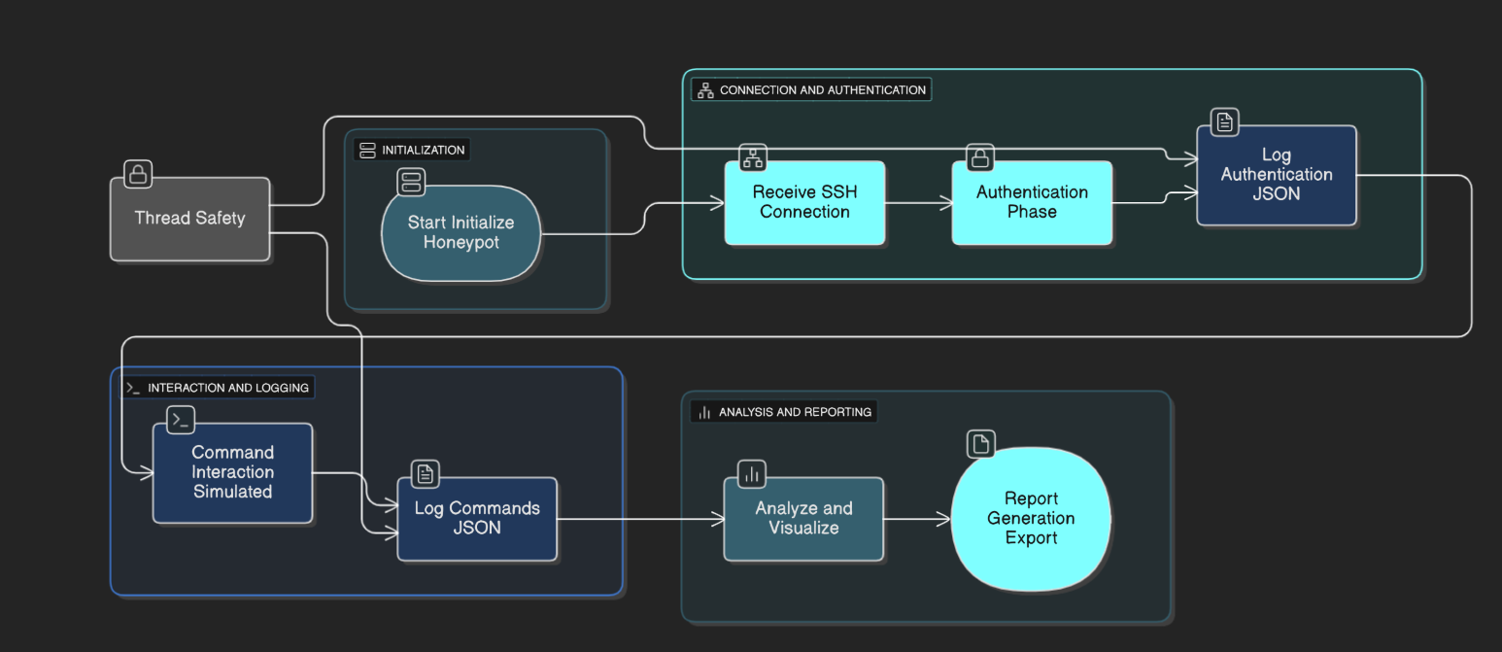
Figure 8 Architecture
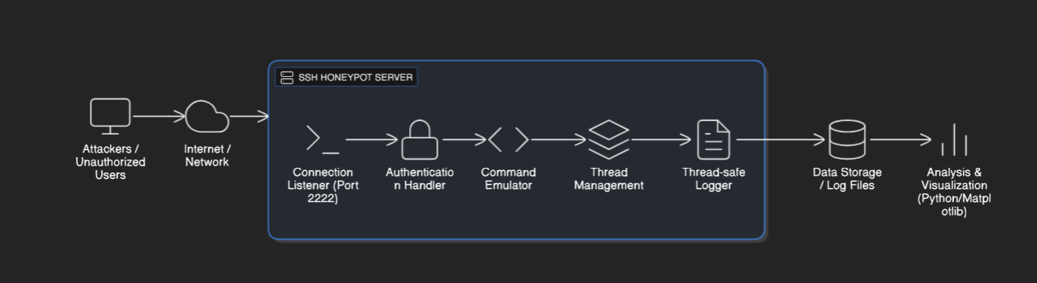
Figure 9 Workflow Layout
Attackers typically begin with reconnaissance automated tools or scripts query IP ranges to discover live hosts. Next comes port scanning to identify open services and potential targets. Once port is detected, attackers attempt credential brute-force (username/password lists) and sometimes public-key probing. Successful or partially successful authentication leads to command execution attempts (enumeration, privilege checks, downloading payloads). Attackers then try to persist, exfiltration, or pivot, but on a honeypot those actions are logged and simulated responses are returned.
Input Layer
- The honeypot sees the attacker’s target IP, source IP, port probed, and initial handshake parameters.
Processing Layer
- Honeypot handles incoming TCP sessions and SSH protocol, matching the port scanner’s connection-attempt loop.
- Logs attempts, timeouts, malformed packets, and tool-specific behavior (rapid retries, simultaneous connections).
Detection Layer
- The system classifies connection results: scan probe, failed auth, successful auth (simulated).
- Marks ports as “probing” vs “exploitation” based on payload patterns and authentication attempts.
Output Layer
- Produces human readable logs and real-time alerts of detected scans, brute-force bursts, and interactive commands.

3.2 Key Components
Configuration Module: This is the first module where the operator configures the honeypot similar to the port-scanner’s user input.
- Functionality: Collects listening IP/interface, listening port, host key file paths, maximum concurrent sessions, and log directory paths (e.g., auth_log.json, commands_log.json).
- Handling: Validates IP addresses and port numbers, checks that host key files and log directories exist or can be created, and ensures required options are not left empty. Provides clear error messages for invalid configuration.
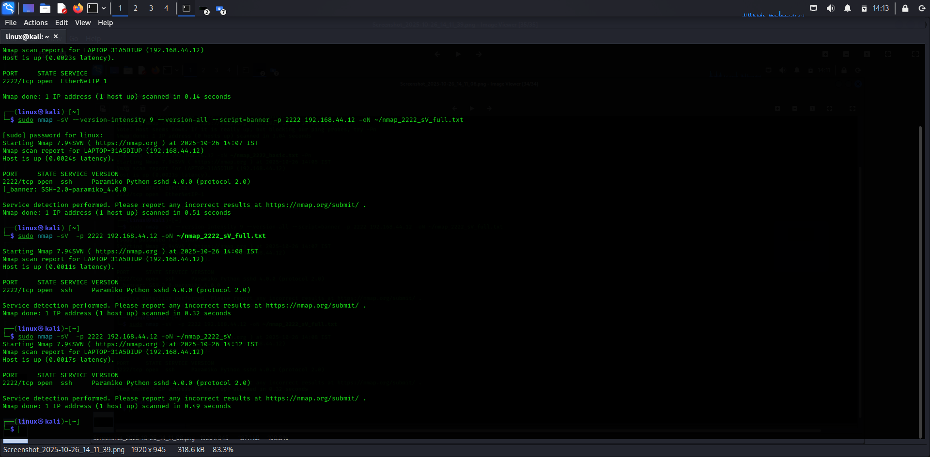
Figure 10 Configuration
Network Listener & Session Management Module: This is the core logical module similar to the port-scanner’s scanning logic. It handles incoming connections and session lifecycle.
- Functionality: Binds and listens on the configured IP/port. For each incoming TCP connection it negotiates the SSH protocol (handshake) and spawns a session object (thread or worker).
- Configuration: Uses a thread pool or worker threads to manage multiple sessions simultaneously, reducing latency and improving throughput. Supports timeouts, per-IP limits and simple rate limiting to protect resources.
Authentication Handler Module: Handles and logs authentication attempts.
- Functionality: Captures password and public-key authentication attempts, records username, password or key fingerprint, client banner, timestamp, and source IP. Optionally returns a simulated “success” under controlled rules to capture post-auth behavior (always contained in the emulated environment).
- Handling: Ensures no real shell or host compromise occurs; simulated sessions run within a safe emulator.
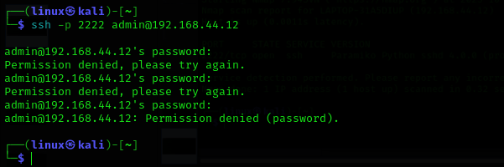
Figure 11 Authentication
Logging & Analysis Module (Output): Stores telemetry and produces human-readable outputs and machine-friendly logs.
- Functionality: Writes structured JSON logs (auth_log.json, commands_log.json, session_meta.json) with fields like timestamp, src_ip, client_banner, username, password_or_key, command, and simulated_output. Ensures thread-safe writes and supports log rotation.
- Handling: Provides console summaries (e.g., New connection from X, Auth attempt: root / 1234 (failed)) and exports data for plotting/analysis (Matplotlib).
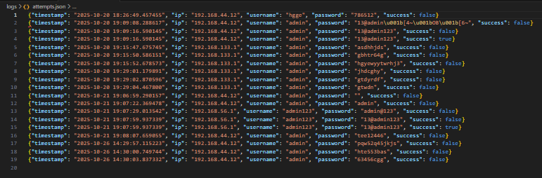
Figure 12 Logs

3.3 Detailed Workflow of Honeypot
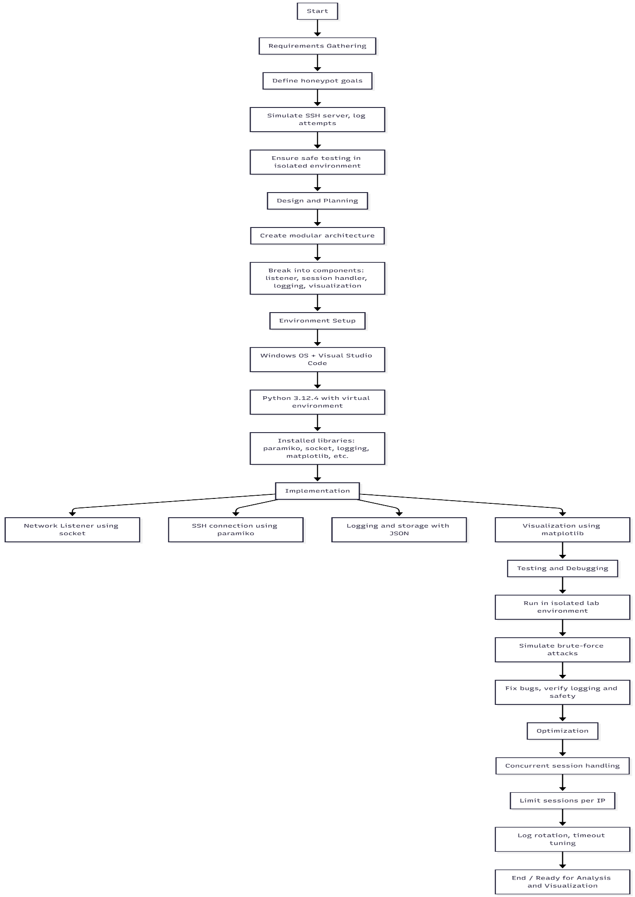
Figure 13 Detailed workflow
Step 1: Start
- Begin SSH honeypot service
Step 2: Accept Incoming SSH Connection
- Listen for TCP connections on defined SSH port (e.g., 2222)
- For each client connection, create/assign a session
Step 3: Handle Authentication Attempt
- Receive username and password from client
- Log attempt (IP, username, password, timestamp) in JSON file
Step 4: Grant or Reject Session
- If credentials match preset, allow access to shell emulation
- If not, close connection and Log event
Step 5: Command Interaction (if session accepted)
- Prompt user for command input
- Log each command (IP, time, command, session data) in command log
- Return minimal/fake output (e.g., fake 'ls' or 'pwd')
Step 10: End
- Service continues unless stopped; results available for security analysis

CHAPTER 4

METHODOLOGY

4.1 Honeypot Operation Workflow
The workflow of the SSH honeypot prioritizes security monitoring and attacker deception by simulating a real SSH server environment. It emphasizes modular logging and safe isolation to prevent any real system compromise. The SSH honeypot works like a fake SSH server that tricks attackers while keeping them away from real systems. It runs inside a safe, isolated environment like a virtual machine or container so nothing can harm the main network. The honeypot opens SSH ports and acts like a normal server, showing login prompts and responses, but it doesn’t actually run any dangerous commands. When someone connects, it records information like the attacker’s IP, the time of connection, and what commands they try. The honeypot also gives fake file views and prepared responses to make the attacker spend more time on it. At the same time, it watches for anything suspicious, like attempts to access other systems, and blocks or limits them immediately. All activity is carefully logged, including session data and network captures, so it can be studied later to understand how attackers behave.
Honeypot Workflow:
- Initializes server and sets up fake SSH environment using Paramiko.
- Listens for incoming TCP connections on a specified port.
- For each connection:
- Records source IP and connection metadata.
- Prompts for authentication (username/password) and logs every attempt to a JSON file.
- Upon “successful” authentication (any credentials, or selected fake ones), creates an emulated shell session.
- Logs every command issued by the attacker into a dedicated JSON commands log.
- Simulates responses for basic Linux commands (e.g., ls, pwd, custom fake files).
- Ends session on “exit” command or after timeout.
- Continuously rotates and stores logs for future forensic analysis.
Output:
The honeypot generates two main log files:
auth_attempts.json records all authentication data (timestamp, IP, credentials).
commands.json logs every command sent in a session.
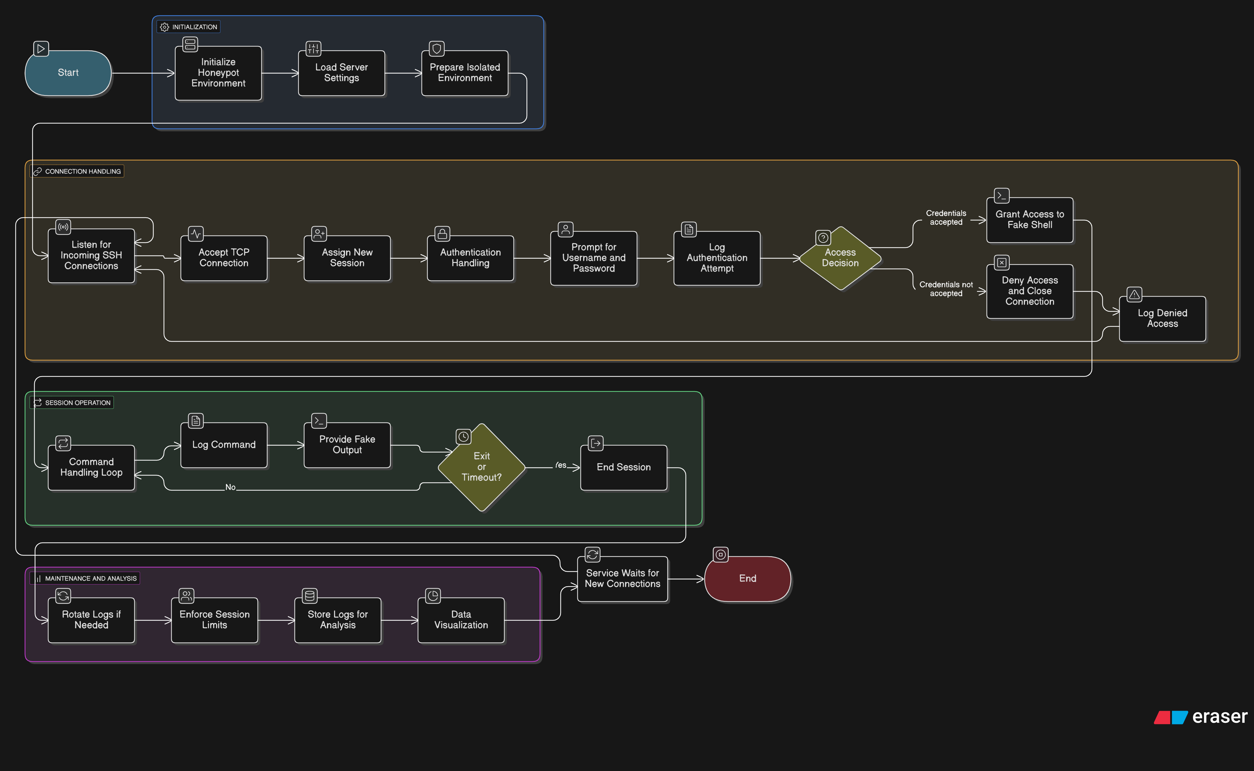
Figure 14 Honeypot Process

4.2 Analysis of Honeypot Data
Input Data:
- Attacker source IPs, timestamps
- Attempted usernames/passwords
- Issued commands during fake shell sessions
Generated Data:
- Data points on brute-force patterns
- Popular attack commands
- Timeline of attacks
Analysis:
- Parse JSON logs to identify frequent attacker IPs and credentials
- Summarize which commands are most commonly tried by attackers
- Visualize trends (e.g., attack frequency by hour, common command analysis) using Matplotlib or other visualization tools

4.3 Security and Containment Measures
Describe how your honeypot is designed to ensure that attackers cannot pivot or affect other systems. Mention:
- Running the honeypot in an isolated VM/lab environment.
- Limiting network permissions.
- Disabling access to real files and system resources.
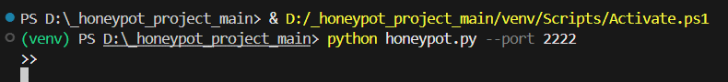
Figure 15 Isolated Environment

4.4 Threat Interaction Logging and Data Management
The honeypot is designed to maximize the quality and organization of captured threat intelligence. For every attacker session, the system meticulously logs not only authentication attempts but also all executed commands in modular, structured JSON files. These logs allow security researchers to reconstruct entire attack sequences, analyze brute-force patterns, and identify new or suspicious behaviors. The adoption of JSON format ensures easy integration with analysis tools and SIEM platforms, while thread-safety guarantees data integrity during high-volume, concurrent attacks.
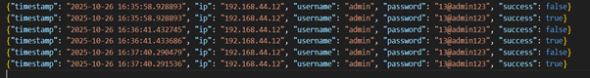
Figure 16 Stored Logs

CHAPTER 5

PROJECT VISUALS

5.1 Visualization of Project and Code Snippet
Code Snippet
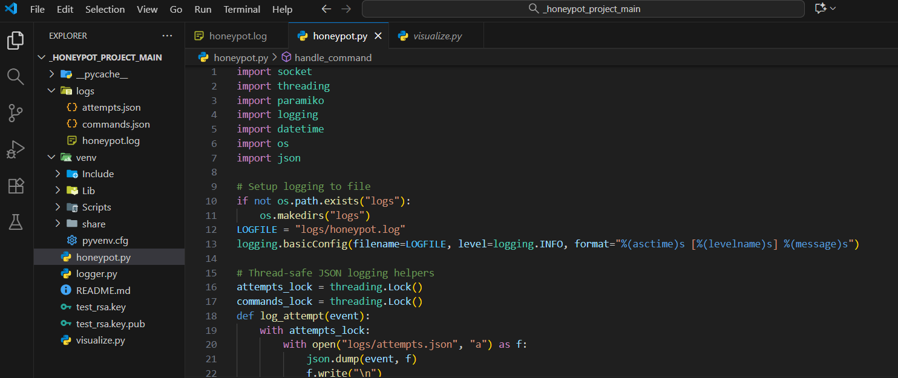
Figure 17 honeypot.py
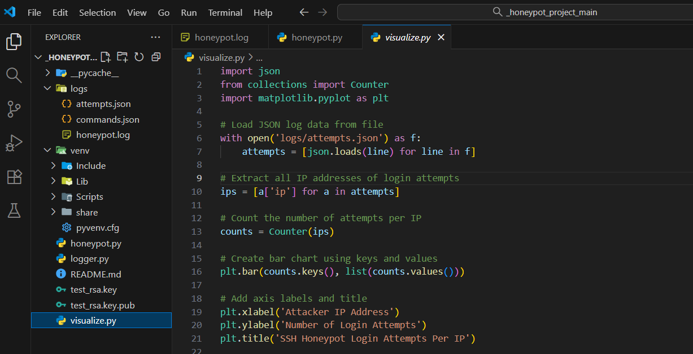
Figure 18 visualize.py
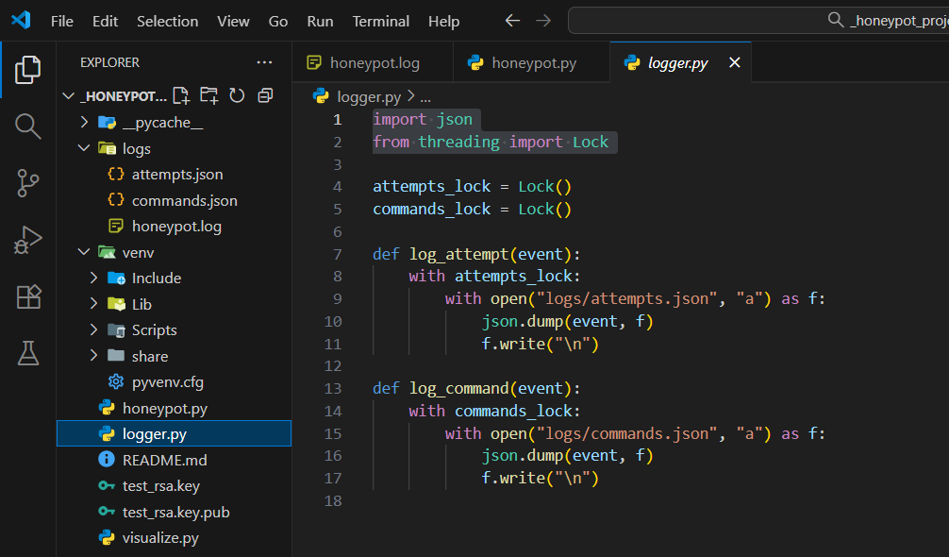
Figure 19 logger.py
Above code snippet are three python files which are the main core logic of a honeypot project these are honeypot.py, which is main core logic which help in running the honeypot. There is logger.py , where logs are stored. There is another file visualize.py which is use visualize the GUI of logs.
Configuration of honeypot
Now we configure the honeypot in the isolated environment. We start the honeypot and visualize file to see the GUI based, logs of attacker.
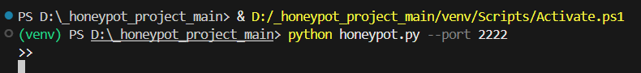
Figure 20 Configuration
Visuals of project
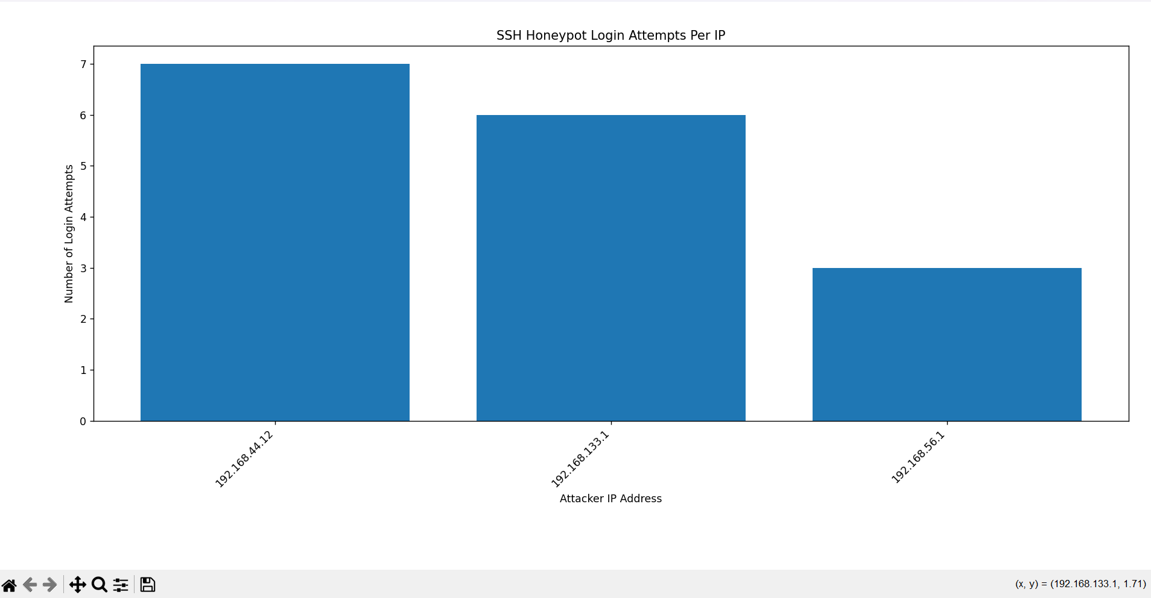
Figure 21 Dashboard

Figure 22 Logs file
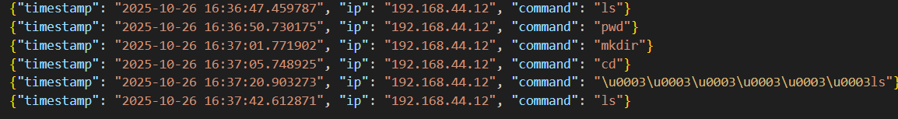
Figure 23 Command file
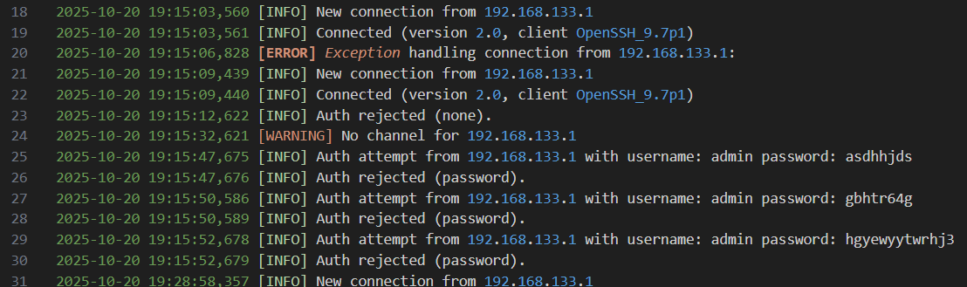
Figure 24 Loggings

Figure 25 Captured attack

CHAPTER 6

EXISTING HONEYPOT SYSTEM

6.1 Introduction to Honeypot System
A honeypot is a cybersecurity mechanism that uses a manufactured attack target to lure cybercriminals away from legitimate targets. They also gather intelligence about the identity, methods and motivations of adversaries.
A honeypot can be modeled after any digital asset, including software applications, servers or the network itself. It is intentionally and purposefully designed to look like a legitimate target, resembling the model in terms of structure, components and content. This is meant to convince the adversary that they have accessed the actual system and encourage them to spend time within this controlled environment.
The honeypot serves as a decoy, distracting cybercriminals from actual targets. It can also serve as a reconnaissance tool, using their intrusion attempts to assess the adversary's techniques, capabilities and sophistication.
The intelligence gathered from honeypots is useful in helping organizations evolve and enhance their cybersecurity strategy in response to real-world threats and identify potential blind spots in the existing architecture, information and network security.

6.2 Overview of Popular Tools
Cowrie Honeypot
A honeypot is a system designed to be placed on a network for the purpose of having attackers to connect to it. Connections to the system are usually not legitimate and allow a network defender to detect the attacker through detailed logging. The logging can reveal not only normal connection information but also session information revealing the techniques, tactics and procedures (TTP) used by the attacker.
The Cowrie Honeypot is a system designed to capture SSH and Telnet connections. Recording the session information. These types of honeypots are often connected to the Internet to monitor the tools, scripts and hosts in use by password guessing attackers.
How the Cowrie honeypot system works
- Mimics real services: Cowrie simulates a standard SSH and Telnet server, complete with a fake Linux shell and filesystem. When an attacker connects to the honeypot, they are presented with a seemingly real, but controlled, server environment.
- Logs attacker activity: The system records all interactions with the attacker in detail. This includes:
- Login attempts: Brute-force attacks and the username/password combinations used.
- Shell commands: The commands entered by the attacker in the fake shell.
- File downloads: Cowrie captures any malware or scripts that the attacker attempts to download onto the fake system.
- Deceives and contains attackers: By providing a convincing but fake environment, Cowrie keeps attackers contained while allowing security professionals to observe their behavior without risk to actual network assets.
- Produces replayable sessions: The system records the attacker's shell interaction in a replayable format, allowing for detailed analysis of their techniques and tactics.
Kippo Honeypot
Kippo is a medium interaction SSH honeypot designed to log brute force attacks and, most importantly, the entire shell interaction performed by the attacker.
Features
- Fake filesystem with the ability to add/remove files. A full fake filesystem resembling a Debian 5.0 installation is included
- Possibility of adding fake file contents so the attacker can 'cat' files such as /etc/passwd. Only minimal file contents are included
- Session logs stored in an UML Compatible format for easy replay with original timings
- Just like Kojoney, Kippo saves files downloaded with wget for later inspection
- Trickery; ssh pretends to connect somewhere, exit doesn't really exit, etc

CHAPTER 7

CASE STUDY - ATTACKS CAPTURED BY THE HONEYPOT
Honeypots are widely used in the real world to detect and study cyber threats. Organizations and security researchers deploy them to attract attackers, learn about their behaviour, and improve overall security.
1. 2023: Valve caught 40,000 Dota 2 cheaters
Valve is a famous gaming company and it found and banned 40,000 players who were cheating in their game Dota 2. They did this by creating a special trap in the game, a part of the game that only cheaters using special tools could access. When players accessed this hidden part, Valve knew they were cheating and banned them. This method helped them catch a large number of cheaters at once and keep the game fair for everyone.
2. 2018: SophosLabs studied the Chalubo botnet
SophosLabs, a cybersecurity research team discovered a type of malware called the Chalubo botnet. This malware infected computers and made them part of a network used for cyber-attacks, especially DDoS attacks. Chalubo mainly targeted computers with weak security, especially those running Linux. The researchers found that Chalubo was designed to hide well and be difficult to detect. They studied its working and it helped them prevent further attacks on it.
3. 2021: Microsoft’s Honeypots Detected IoT Attacks
In 2021, Microsoft deployed honeypots to observe attacks on Internet of Things (IoT) devices such as smart cameras and routers. These fake systems were designed to attract attackers using weak passwords and outdated software. The data collected showed that many of the attacks came from automated bots building large botnets. This research helped Microsoft strengthen its cloud security and protect real IoT devices from similar threats.
4. 2024: AI-powered honeypot traps 800,000+ interactions
In October 2024, researchers deployed a honeypot configured with a vulnerable SSH version and attractive network fingerprints The system recorded more than 813,202 interaction attempts, including six apparently AI-powered hacking agents. This study highlights the shifting attacker landscape automated adversaries (including AI agents) scanning and probing at massive scale and shows how honeypots can capture very large volumes of data for analysis of both human and machine-driven attacks.

CHAPTER 8

PROJECT REQUIREMENTS

8.1 Software Requirements
The software requirements for this project are listed below:
Window OS
Python
VS Code
Virtual Box
Kali Linux
Parrot OS

8.2 Hardware Requirements
The hardware requirements for this project are listed below:
a. Minimum Hardware Requirements
      - 512GB SSD
      - 16GB RAM
      - Intel Core i5 11 Generation Processor or equivalent
b. Recommended Hardware Requirements
- 2TB SSD
- 32GB RAM or more
- Intel Core i7 14th Generation or equivalent

CHAPTER 9

FUTURE SCOPE
With the rapid advancement of cyber threats, future honeypot systems will leverage artificial intelligence and cloud-managed architectures to adaptively deceive and engage attackers. The integration of honeypots with SIEM platforms, real-time analytics, and enhanced deceit techniques will enable organizations to generate actionable intelligence and strengthen incident response against increasingly sophisticated attacks.
AI-Driven Honeypots: The current of honeypot research is focused on adaptive systems powered by artificial intelligence and machine learning. Such honeypots can dynamically change their interaction patterns, anticipate attacker moves, and evade fingerprinting methods, providing deeper insights into emerging threats and making detection by adversaries more challenging.
Focus on IoT and Cloud Security: With the expansion of IoT and cloud technologies, honeypots tailored for these environments are critical for detecting specialized attacks unique to these platforms. Adaptive honeypots for IoT and edge computing will provide new research and defence opportunities
Integration with SIEM and Threat Intelligence Platforms: Modern honeypots are increasingly integrated with SIEM solutions and threat intelligence platforms, allowing real-time alerting and automated response to detected malicious activities. This integration supports rapid incident response, automated threat blocking, and improved forensic capabilities.
Honeypot-as-a-Service: As managed security services evolve, honeypot-as-a-service is emerging, lowering barriers to adoption for organizations lacking in-house expertise and enabling full lifecycle management with low overhead.
Academic and Industry Applications: Real-world honeypot deployments in universities, research labs, and enterprise SOCs contribute valuable threat data for both teaching and practical security improvements.

CHAPTER 10

CONCLUSION
In conclusion The role of intrusion- detection technology based on the decoy, or “Honeypot”, is evolving. Once primarily used by researchers as a way to attract hackers to a network system to study their movements and behaviour, honeypots are now beginning to play an important role in the security of enterprises. Indeed, honeypots are proving to be more useful to IT security professionals than ever, by providing early detection of unauthorized network activity.
The results showed that honeypots play an important role in proactive cybersecurity strategies by providing early warnings and helping in threat intelligence collection. Overall, this project helped build a deeper understanding of intrusion detection techniques, system vulnerabilities, and ethical considerations while dealing with live network data.
Future work can involve integrating this honeypot with automated alert systems, visualization dashboards, or cloud-based analytics platforms to create a more advanced and interactive defence system.

REFERENCES

